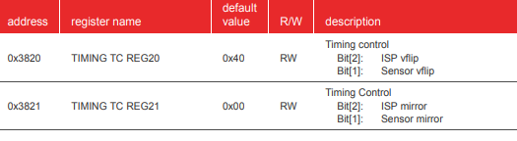For vertical flip

For mirroring





Test pattern color bar

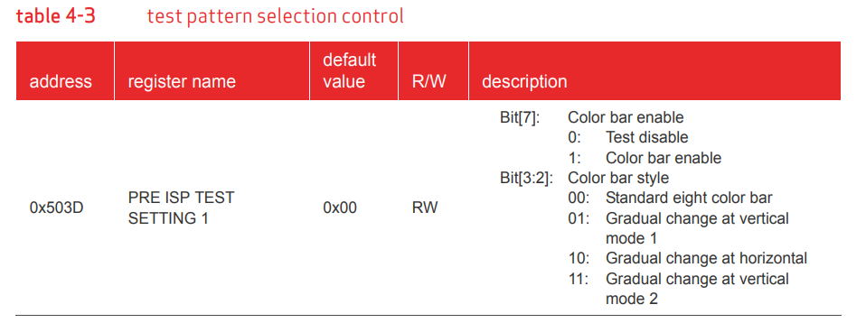

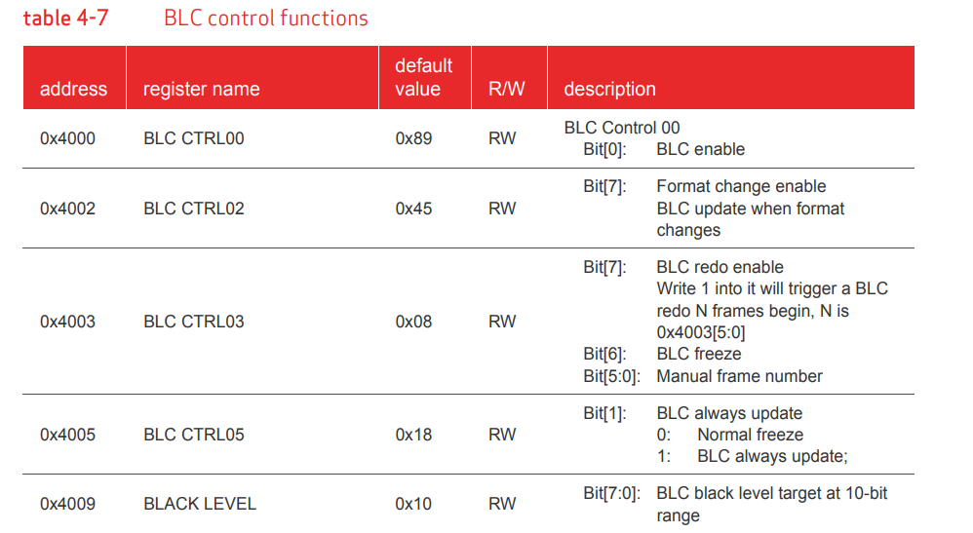Black level calibration

Defect pixel cancellation (DPC)

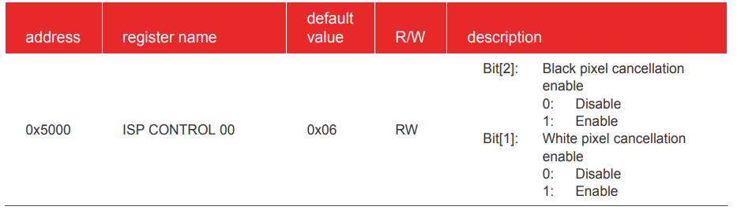

Color interpolation (CIP)

The CIP functions include de-noising of raw images, RAW to RGB interpolation, and edge enhancement. In sensor RAW format, each pixel will be either R, G or B. CIP will calculate the other two color values using the neighboring pixel of the same color. Thus, we can get the full RGB information for each pixel.

Pg#68

5.3 auto white balance (AWB)

The AWB makes sure that the white color is always a white color in different color temperatures. It supports manual white balance and auto white balance.

Page :64

Table: 5-3

5.4 raw gamma

The main purpose of the Gamma (GMA) function is to compensate for the non-linear characteristics of the sensor. GMA converts the pixel values according to the Gamma curve to compensate the sensor output under different light strengths. The non-linear gamma curve is approximately constructed with different linear functions. Raw gamma compensates the image in the RAW domain.

**5.11 special digital effects (SDE)**

The Special Digital Effects (SDE) functions include hue/saturation control, brightness, contrast, etc. SDE also supports negative, black/white, sepia, greenish, blueish, redish, solarize and other image effects.

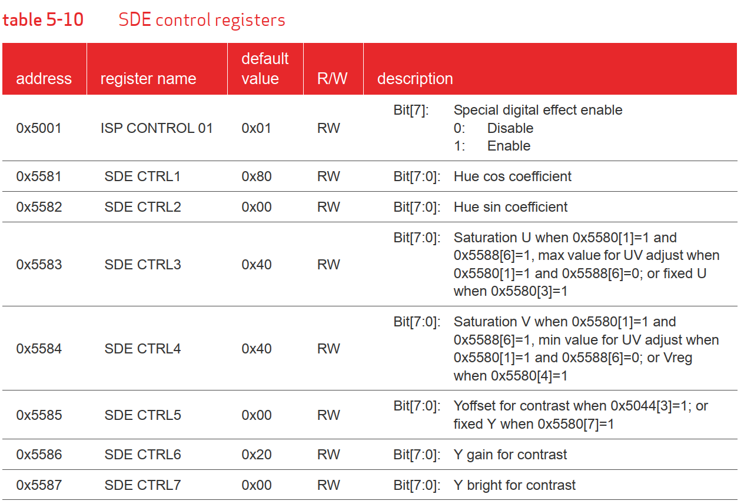

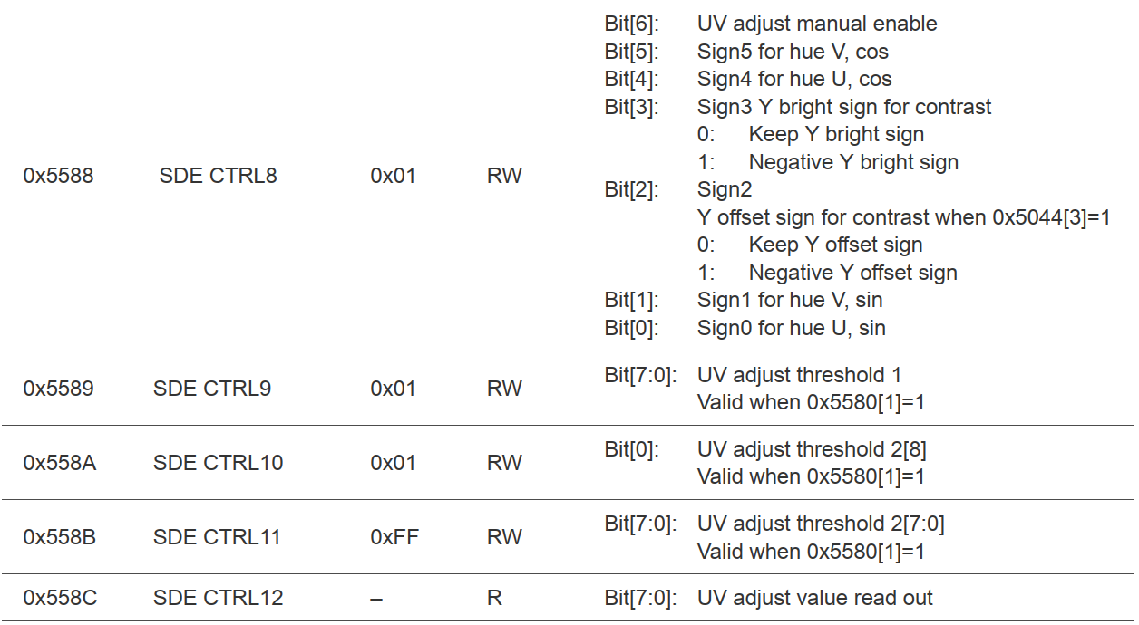

**5.10 UV adjust**

The UV adjust function is integrated in SDE. The main function of the UV adjust is to adjust the U/V channel value according to sensor gain. It supports both manual and auto modes.

**4.5 AEC/AGC algorithms**

The Auto Exposure Control (AEC) and Auto Gain Control (AGC) allows the image sensor to adjust the image brightness to a desired range by setting the proper exposure time and gain applied to the image. Besides automatic control, exposure time and gain can be set manually from external control. The related registers are listed in table 4-4.